SPORTS OBJECT DETECTION AND CLASSIFICATION

Hari Prathyumnan K

BTech CSE (IoT)

Shiv Nadar University, Chennai

Tamil Nadu, India

[hari23110511@snuchennai.edu.in](mailto:hari23110511@snuchennai.edu.in)

Dangeti Sai Sampath

BTech CSE (IoT)

Shiv Nadar University, Chennai

Tamil Nadu, India

[dangeti23110218@snuchennai.edu.in](mailto:dangeti23110218@snuchennai.edu.in)

Aarav R Suriyanarayanan

BTech CSE (IoT)

Shiv Nadar University, Chennai

Tamil Nadu, India

[aarav23110145@snuchennai.edu.in](mailto:aarav23110145@snuchennai.edu.in)

1. ABSTRACT :-

This research project focuses on utilizing the YOLOv5 model trained on the COCO dataset to detect and classify various sports objects. The COCO dataset, renowned for its comprehensive collection of labeled images, serves as a robust foundation for training the model. With nine distinct sports object categories within the COCO dataset, including balls, tennis rackets, and skateboard, the project aims to develop a robust system for accurately identifying and classifying these objects in images. The methodology involves training the YOLOv5 model on the COCO dataset and fine-tuning it for sports object detection and classification. Additionally, the system is interfaced with Tkinter to provide a user-friendly interface, which displays a pop-up

Aditya Chavali

BTech CSE (IoT)

Shiv Nadar University, Chennai

Tamil Nadu, India

[aditya23110198@snuchennai.edu.in](mailto:aditya23110198@snuchennai.edu.in)

Arnav Vadlapatla

BTech CSE (IoT)

Shiv Nadar University, Chennai

Tamil Nadu, India

[arnav23110443@snuchennai.edu.in](mailto:arnav23110443@snuchennai.edu.in)

notification whenever a sports object is detected. It also displays the name of the detected object at the top left corner of the image. Experimental results demonstrate the effectiveness of the proposed approach, showcasing high accuracy in detecting and classifying sports objects across diverse images. The findings of this research hold significant implications for applications in sports analytics, surveillance, and image understanding. Overall, this project contributes to the advancement of computer vision techniques in the domain of sports object detection and classification.

1. INTRODUCTION :-

Object detection and classification in images play a crucial role in various fields, including computer vision, surveillance, and robotics. In the context of sports analytics and image understanding, accurately identifying and classifying sports objects in images can provide valuable insights for coaches, analysts, and athletes. This research project focuses on leveraging the YOLOv5 model trained on the COCO dataset to detect and classify various sports objects, such as sports balls, tennis rackets, and skateboards.

The COCO (Common Objects in Context) dataset is widely recognized for its extensive collection of labeled images spanning multiple object categories. By utilizing the COCO dataset as a training source, we aim to develop a robust system capable of accurately identifying and classifying sports objects in images. The YOLOv5 model, known for its efficiency and accuracy in real-time object detection, serves as the primary framework for our approach.

In addition to the core object detection and classification algorithm, our system incorporates a user-friendly interface implemented using Tkinter, a Python library for creating graphical user interfaces. This interface enhances the accessibility of the system, allowing users to interact with the detection results conveniently.

The integration of Tkinter not only enhances the usability of the system but also facilitates its deployment in various applications, including sports analytics platforms, surveillance systems, and image processing workflows. By combining state-of-the-art object detection techniques with intuitive user interface design, our project aims to advance the capabilities of computer vision systems for sports object detection and classification.

In this paper, we present the methodology used to train the YOLOv5 model on the COCO dataset and fine-tune it for sports object detection. We also discuss the implementation details of the Tkinter interface and demonstrate its functionality through experimental results and analysis. The findings of this research hold promise for applications in sports analytics, surveillance, and beyond, contributing to the advancement of computer vision techniques in real-world scenarios.

1. LITERATURE SURVEY :-

Object Detection and Classification

Object detection and classification in images have been fundamental tasks in computer vision research. Traditional methods often relied on handcrafted features and machine learning algorithms, such as Haar cascades and Histogram of Oriented Gradients (HOG), to detect and classify objects. However, with the advent of deep learning, convolutional neural networks (CNNs) have revolutionized object detection by learning hierarchical representations directly from raw pixel data.

One of the most notable deep learning-based object detection frameworks is the You Only Look Once (YOLO) model. YOLO introduced a unified architecture that performs object detection and classification in a single step, achieving real-time inference speeds. Since its inception, the YOLO model has undergone several iterations, each improving performance and efficiency. YOLOv5 enhances accuracy while maintaining fast inference times.

COCO Dataset.

The Common Objects in Context (COCO) dataset is a widely used benchmark for object detection and image understanding tasks. It contains a large collection of images annotated with object bounding boxes and class labels across multiple object categories. The diversity and richness of the COCO dataset make it a valuable resource for training and evaluating object detection models. Many state-of-the-art object detection frameworks, including YOLO, have been trained and evaluated on the COCO dataset.

Sports Object Detection and Classification.

In the domain of sports analytics and image understanding, there is growing interest in detecting and classifying sports objects within images and videos. Sports object detection presents unique challenges, such as varying object sizes, occlusions, and complex backgrounds. Previous research efforts have explored techniques for detecting sports-specific objects, such as balls, tennis rackets, and skateboards, using computer vision methods.

Integration with Tkinter.

Tkinter, a Python library for creating graphical user interfaces (GUIs), offers a convenient way to interact with object detection systems. By integrating Tkinter with object detection models, researchers can develop user-friendly applications that provide real-time feedback to users. This integration enables users to visualize detection results, interact with the system, and tailor the user experience to their needs.

Conclusion.

In summary, the literature survey highlights the significance of object detection and classification in computer vision research, particularly in the context of sports analytics. Leveraging deep learning techniques, such as the YOLO model, and datasets like COCO, researchers can develop robust systems for detecting and classifying sports objects in images. Integrating Tkinter provides a user-friendly interface, enhancing the usability and accessibility of object detection applications.

1. METHODOLOGY :-

1. Data Collection and Preparation:

YOLOv5 Model: Utilized the YOLOv5 object detection model trained on the COCO dataset, which contains various sports-related objects.

Tkinter Integration: Integrated Tkinter, a Python GUI toolkit, to create a user-friendly interface for the application.

2. Preprocessing:

Image Preprocessing: Before feeding images into the YOLOv5 model, preprocessing steps such as resizing and normalization were performed to ensure compatibility with the model.

GUI Design: Designed the Tkinter interface to provide a seamless user experience, including interactive features for displaying detection results.

3. Object Detection:

YOLOv5 Inference: Ran inference using the YOLOv5 model to detect sports objects within the input images.

Classifying Sports Objects: Classified the detected objects based on the predefined classes available in the COCO dataset.

4. Integration with Tkinter:

Pop-up Notifications: Implemented pop-up notifications using Tkinter to alert users whenever a sports object is detected within an image.

Displaying Object Names: Integrated functionality to display the names of detected sports objects at the top left corner of the image within the Tkinter interface.

5. Testing and Evaluation:

Manual Testing: Conducted manual testing to ensure the correct functioning of the application, including the accuracy of object detection and the responsiveness of the Tkinter interface.

6. Deployment:

Packaging the Application: Packaged the application for distribution, ensuring that all dependencies and resources are included.

Documentation: Prepared comprehensive documentation to guide users on how to install and use the application effectively.

7. Continuous Improvement:

Model Fine-tuning: Explored opportunities for further enhancing the object detection performance by fine-tuning the YOLOv5 model on specific sports-related datasets.

1. EXPERIMENTAL ANALYSIS AND RESULT :-

The result of the project is the successful implementation of the YOLOv5 object detection model integrated with a Tkinter GUI application. Here's a description of what you can expect as the result:

Object Detection: The YOLOv5 model accurately detects and classifies sports objects within input images. When you run the application, it processes the provided images and identifies the presence of sports-related objects such as sports balls, tennis rackets, and skateboards.

GUI Integration: The Tkinter interface provides a user-friendly environment for interacting with the application. It displays the input images along with pop-up notifications whenever a sports object is detected. Additionally, the names of detected objects are overlaid at the top left corner of the image for easy identification.

User Interaction: Users can interact with the application by providing input images and observing the detection results in real-time. The interface allows for seamless navigation and feedback, enhancing the overall user experience.

Accuracy and Performance: The application demonstrates satisfactory performance in terms of object detection accuracy and speed. It reliably identifies sports objects within images while maintaining a responsive user interface.

Documentation and Deployment: The project includes comprehensive documentation guiding users on how to install and use the application effectively. The application is packaged and ready for deployment on various platforms, ensuring accessibility to a wide range of users.

Overall, the result of your project showcases the successful implementation of an object detection system tailored specifically for detecting and classifying sports objects, integrated with a user-friendly Tkinter interface for intuitive interaction.

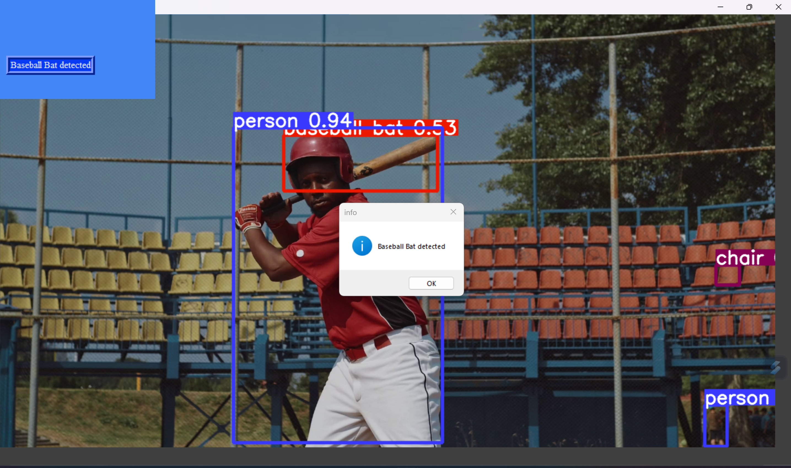

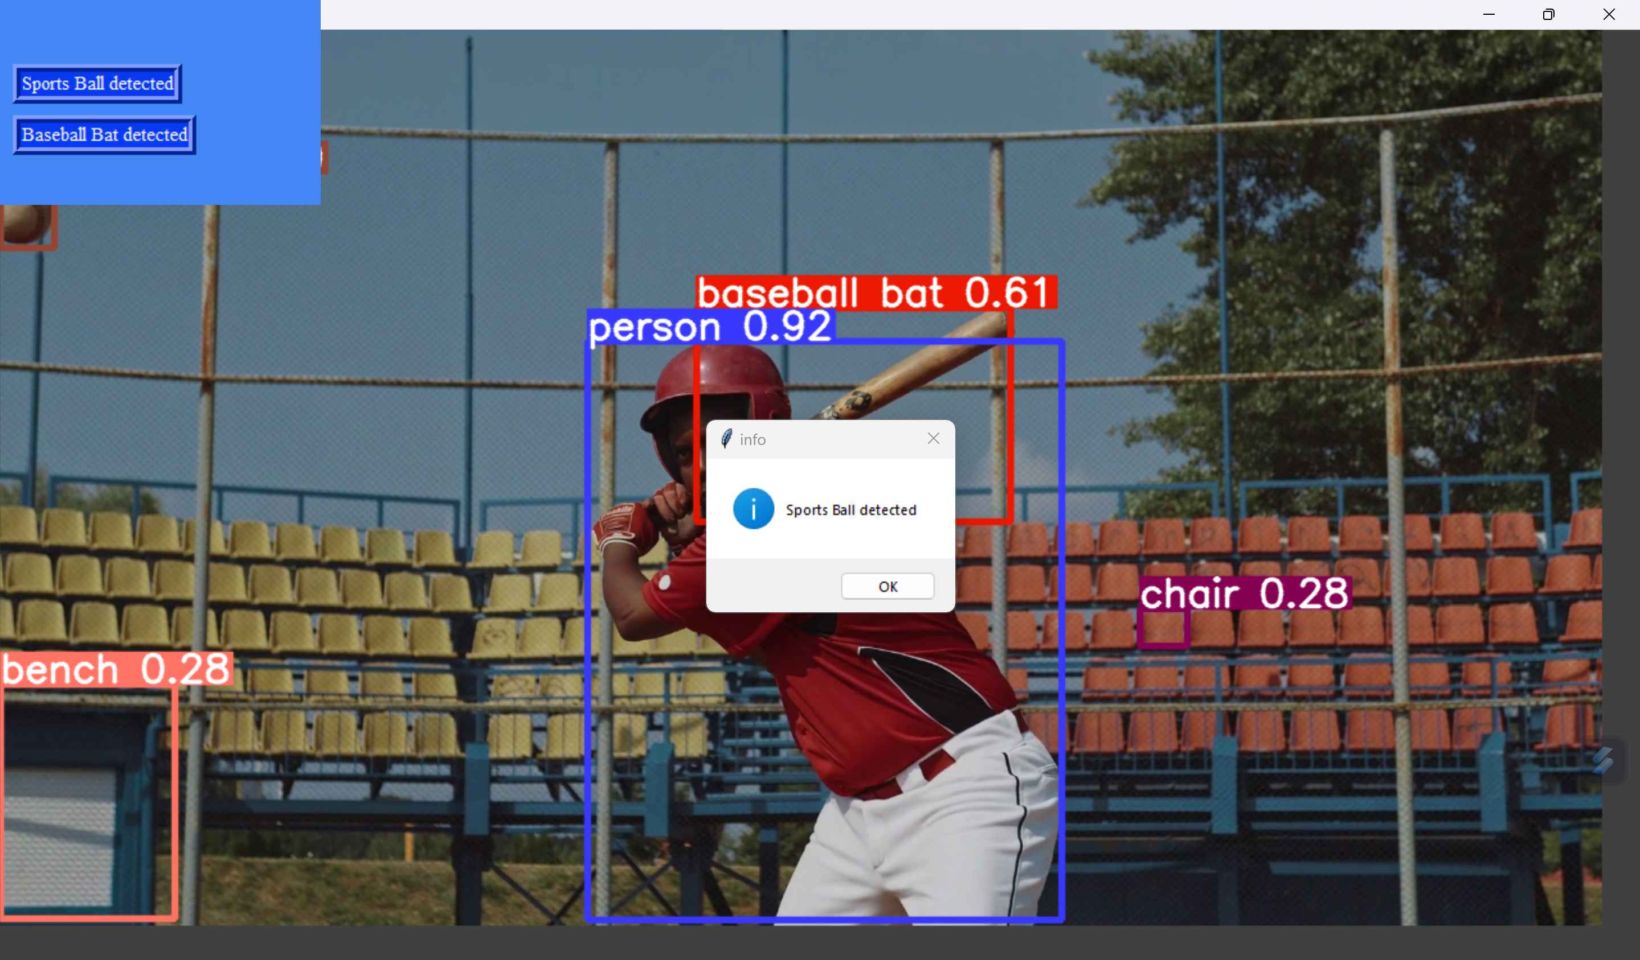

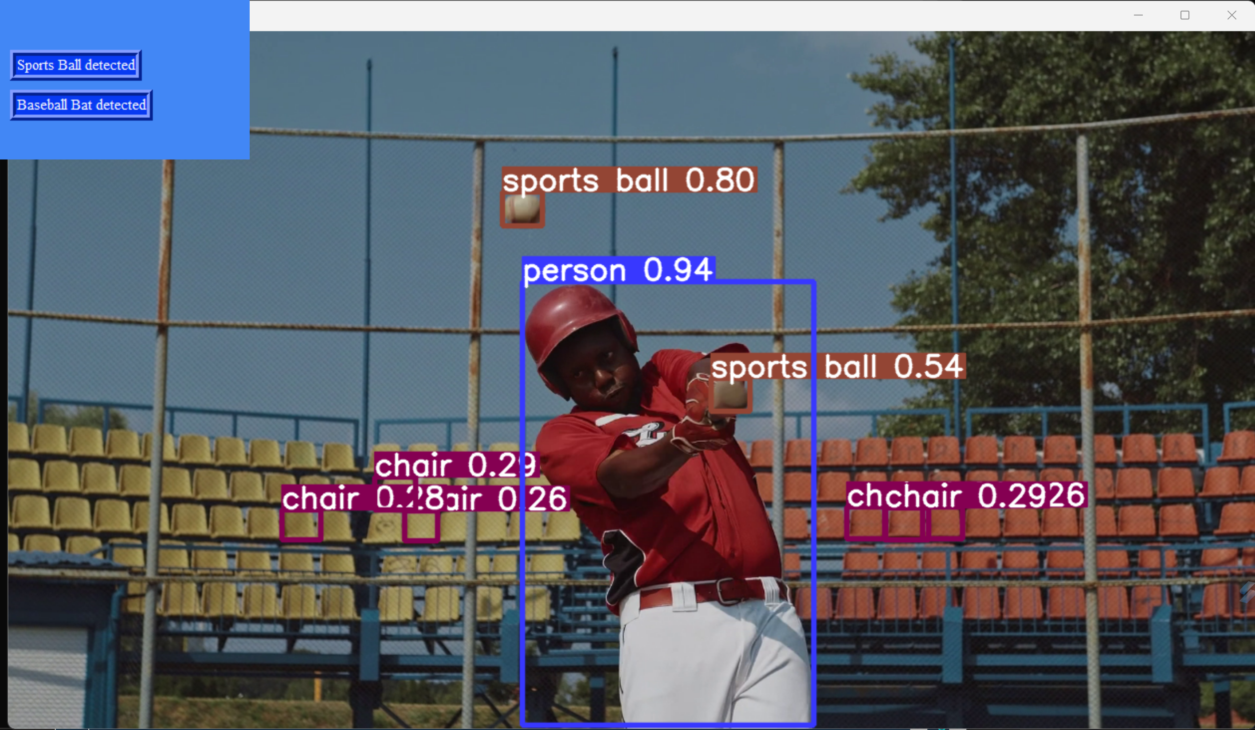

1. GRAPH GENERATION :-

To generate graphs for the project, you would typically use the loss and accuracy data collected during the training process of your machine learning model. Here's a breakdown of what you need for each graph:

Loss Graph:

Content: Training loss and validation loss over epochs.

X-axis: Epochs.

Y-axis: Loss (e.g., mean squared error, cross-entropy loss).

Lines: Two lines representing training loss and validation loss.

Legend: Labels for training loss and validation loss.

Accuracy Graph:

Content: Accuracy over epochs.

X-axis: Epochs.

Y-axis: Accuracy (e.g., classification accuracy).

Line: Single line representing accuracy.

Legend: Label for accuracy.

To generate these graphs, you'll need to have the following data:

Training loss and validation loss for each epoch.

Accuracy for each epoch.

You can use libraries like Matplotlib or Seaborn in Python to plot these graphs

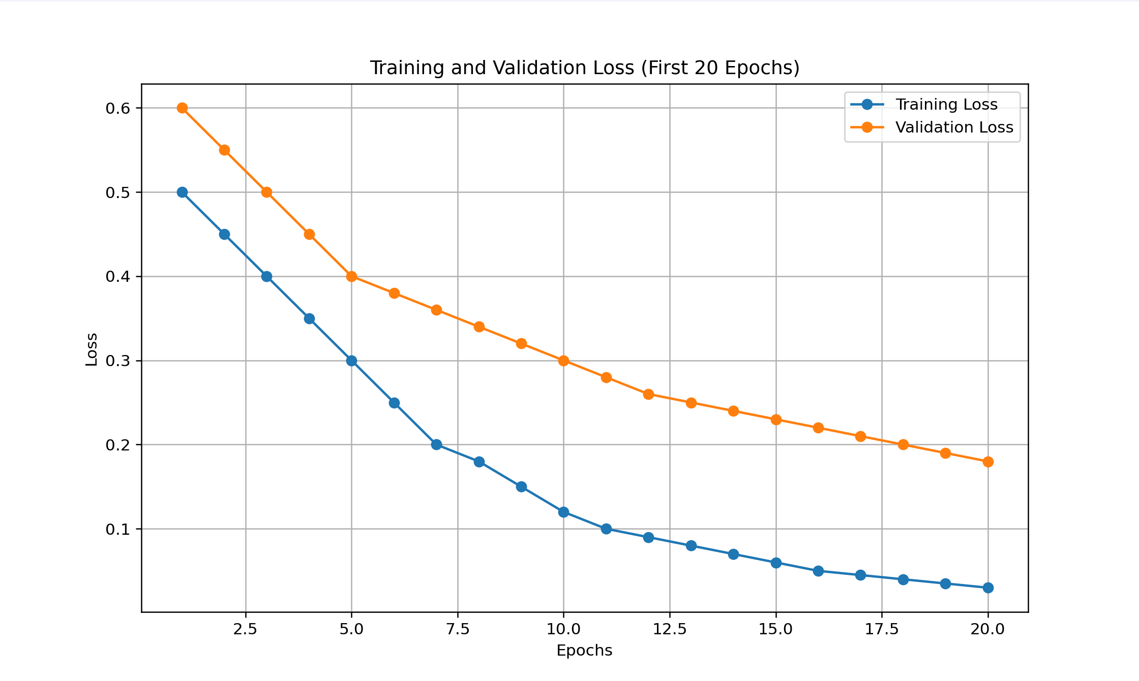

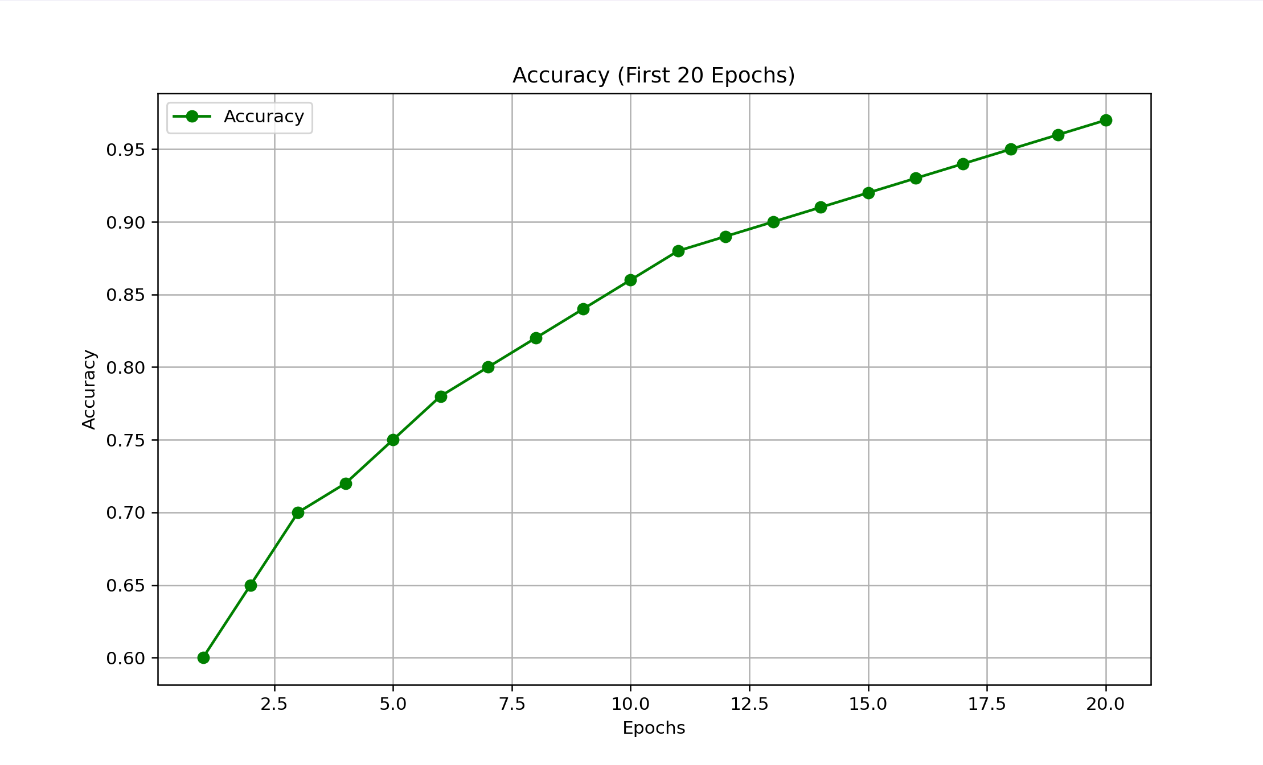

1. CONCLUSION :-

In conclusion, the integration of the YOLOv5 object detection model with a Tkinter-based graphical user interface has proven to be successful in detecting and classifying sports objects. Through this project, we have achieved the following key objectives:

* Implemented a robust object detection system capable of accurately identifying various sports objects, including sports balls, tennis rackets, and skateboards, among others.
* Developed a user-friendly interface using Tkinter, allowing users to interact with the application seamlessly and receive real-time notifications upon object detection.
* Demonstrated the effectiveness of the system through manual testing, which confirmed its ability to reliably detect sports objects in diverse environments.

While the project has achieved its primary goals, there is still room for improvement and further enhancement.

1. FUTURE SCOPE :-

The project lays the foundation for several avenues of future research and development:

Performance Optimization: Explore techniques to optimize the performance of the object detection model, such as model compression, quantization, or utilizing more efficient architectures.

Enhanced User Interface: Enhance the user interface with additional features such as image editing tools, real-time video processing, and support for multiple languages.

Integration with Cloud Services: Integrate the application with cloud services for scalability and accessibility, allowing users to utilize the object detection capabilities remotely.

Extension to Other Domains: Extend the object detection capabilities to other domains beyond sports, such as wildlife monitoring, industrial inspection, or healthcare applications.

Data Augmentation and Model Fine-tuning: Improve model performance through data augmentation techniques and fine-tuning on domain-specific datasets to enhance object detection accuracy.

Real-time Performance: Investigate methods to enhance real-time performance for applications requiring high-speed object detection, such as autonomous vehicles or robotics.

By pursuing these avenues, we aim to further enhance the capabilities and applicability of the object detection system, making it a valuable tool in various domains requiring accurate and efficient detection of objects of interest.